TP1- Partie2 :

1)

a) i-

declare

moyenne number := 0;

begin

for i in (select department_id, employee_id, last_name from employees) loop

SELECT avg(salary) into moyenne from employees where employee_id = i.employee_id;

dbms_output.put_line ('le departement : '||i.department_id||' l employee numero : '||i.employee_id||' son nom est '||i.last_name||' son salaire moyen : '||moyenne);

end loop;

end;

/

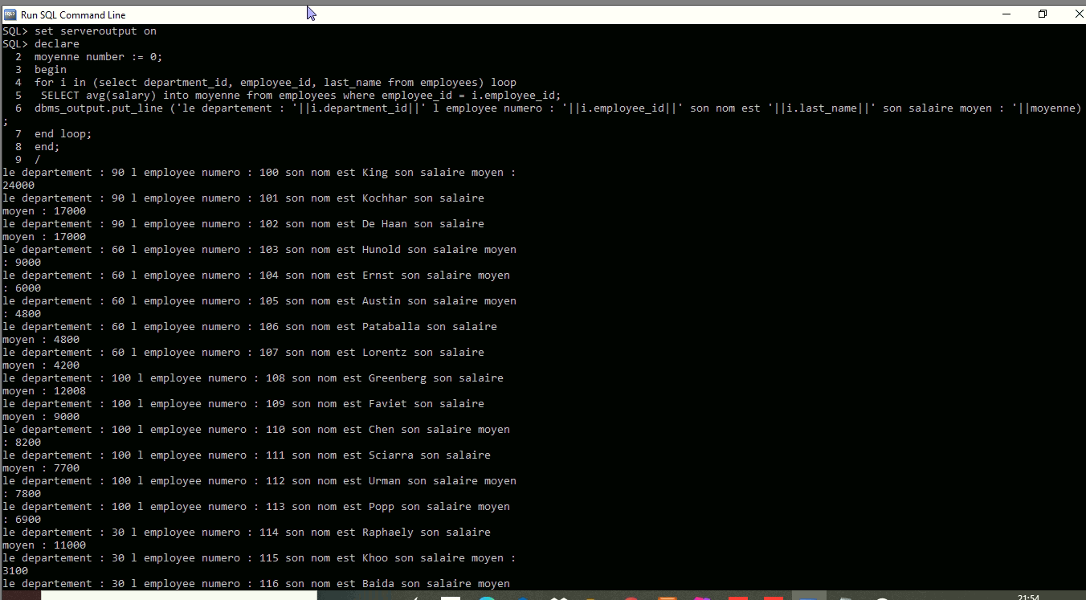

ii-

Declare

Cursor c is (SELECT department_id, employee_id, last_name from employees);

departement employees.department_id%Type;

identifiant employees.employee_id%Type;

nom employees.last_name%Type;

moyenne number := 0;

Begin

open c;

loop

fetch c into departement, identifiant, nom;

SELECT avg(salary) into moyenne from employees where employee_id = identifiant;

exit when c%notfound;

DBMS_OUTPUT.put_line('le departement : '||departement||' l employee numero : '||identifiant||' son nom est '||nom||' son salaire moyen : '||moyenne);

end loop;

close c;

end;

/

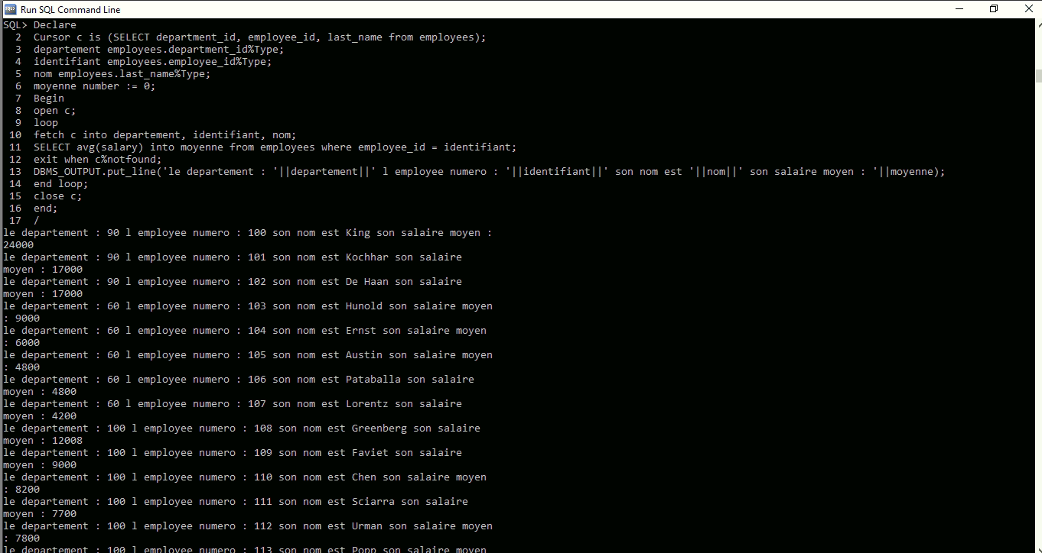

b)

declare

cursor c is (select distinct department_id from employees);

departement employees.department_id%Type;

nombre_emp number := 0;

Begin

open c;

loop

fetch c into departement;

SELECT count(*) into nombre_emp from employees where department_id = departement;

exit when c%notfound;

DBMS_OUTPUT.put_line('le departement : '||departement||' le nombre des employes est : '||nombre_emp);

end loop;

close c;

end;

/

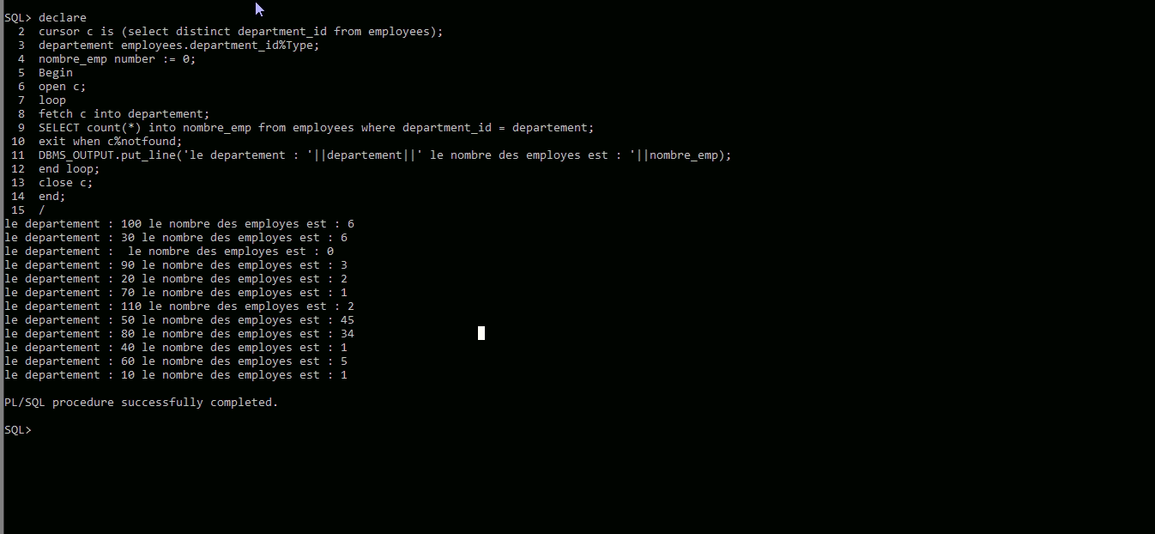

c-

declare

cursor c is (select department_id, first_name from employees);

departement employees.department_id%Type;

nom employees.first_name%Type;

nombre_emp number := 0;

Begin

open c;

loop

fetch c into departement, nom;

SELECT count(*) into nombre_emp from employees where department_id = departement;

exit when c%notfound;

IF nombre_emp > 20 THEN

DBMS_OUTPUT.put_line('le departement est '||departement||' l employe est '||nom);

END IF ;

end loop;

close c;

end;

/

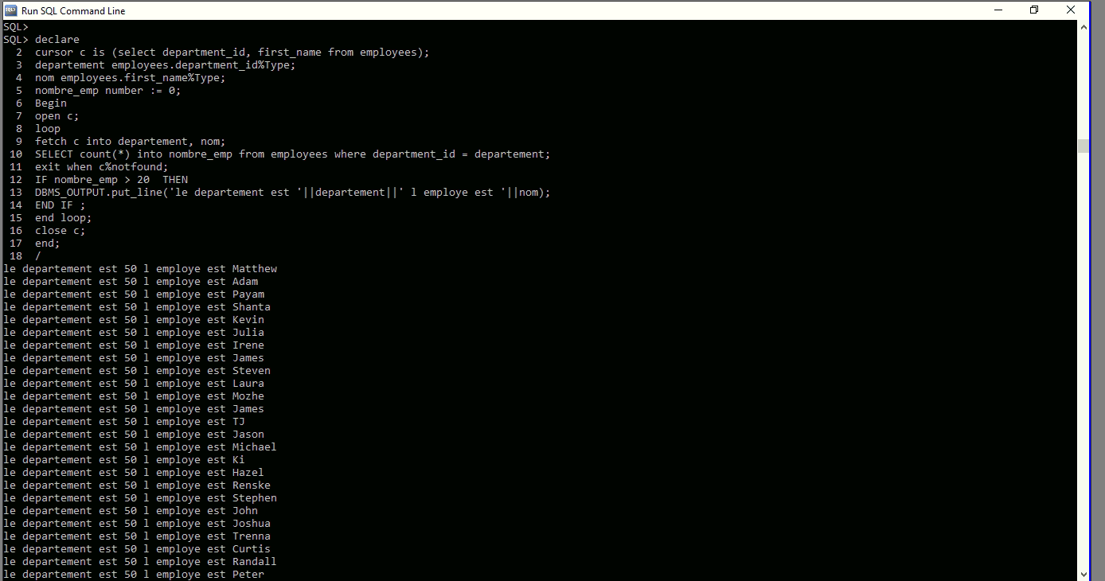

d)

declare

cursor c(d number) is (select employee_id, first_name, last_name from employees where employee_id = d);

prenom employees.first_name%Type;

nom employees.last_name%Type;

begin

for i in c(101) loop

select first_name, last_name into prenom,nom from employees WHERE manager_id = 101;

DBMS_OUTPUT.put_line('le manager est '||i.last_name||' '||i.first_name||' son employe est '||nom||' '||prenom);

end loop;

end;

/

2)

DECLARE

ddl_qry VARCHAR2 (150);

BEGIN

ddl_qry := 'CREATE TABLE produits (idProduit number primary key, nomProduit varchar(20), categorieP varchar(20), prixProduit number)';

EXECUTE IMMEDIATE ddl_qry;

END;

/

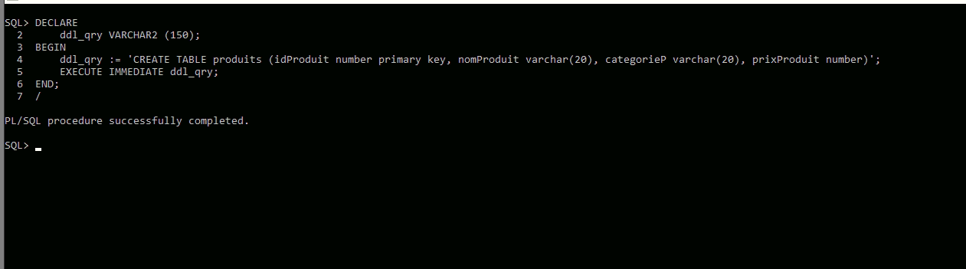

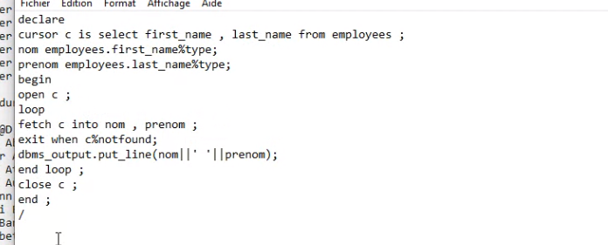

Explicite

Implicite (sans declare)

